**Title:** Lab 5: AC-to-DC Rectifier

**Name:** Robert Bara **Partner:** Abdulaziz Almersi

**General Objective:** An AC-DC rectifier can be accomplished by wiring a diode-bridge. This lab investigates how a diode bridge functions by simulating the rectifier in Multisim and analyzing the signal’s waveforms by using the NI Instrument’s Oscilloscope, whilst varying the circuits conditions.

**Background Activities:**

Rectifier circuits are circuits consisting of diodes that when wired correctly, will convert an AC source into DC power. Rectifiers can be classified as two kinds of circuits: Half-wave Rectifiers which only pass through one polarity and Full-wave Rectifiers which inverts the negative polarity into a positive polarity so that the entire waveform is used.

**Procedure**

**PART I:**

Start by creating a simple bridge rectifier in Multisim consisting of four forward biased diodes in the same direction, creating a typical bridge rectifier. Simulate the circuit and use an oscilloscope to help understand how the rectifier flows current through the positive half and negative half of the signal’s cycle. The circuit schematic is shown below:

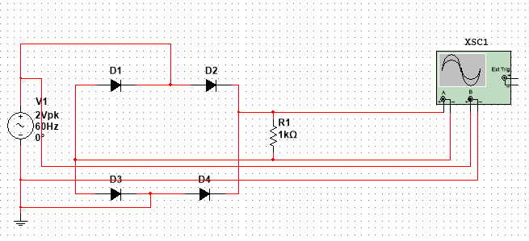

Figure . Bridge Rectifier Simulation

**PART II:**

Using the NI ELVIS II/II+ tools within Mulisim, simulate a full-wave bridge rectifier. This can be done by connecting the AI 0+ and AI 0- buses across the load resistor. Next connect AI 1+ and AI 1- to the NI ELVIS II’s function generator and ground. Set the Function Generator to have a frequency of 60Hz and 10Vpp amplitude. Wire the NI ELVIS II’s oscilloscope to enable channel 0’s positive probe to AI 0 and the negative probe to AI 1. Wire channel one’s positive probe to AI 1 and the negative probe to ground. This will compare the voltage across the load to the input wave. The schematic should be appear as follows:

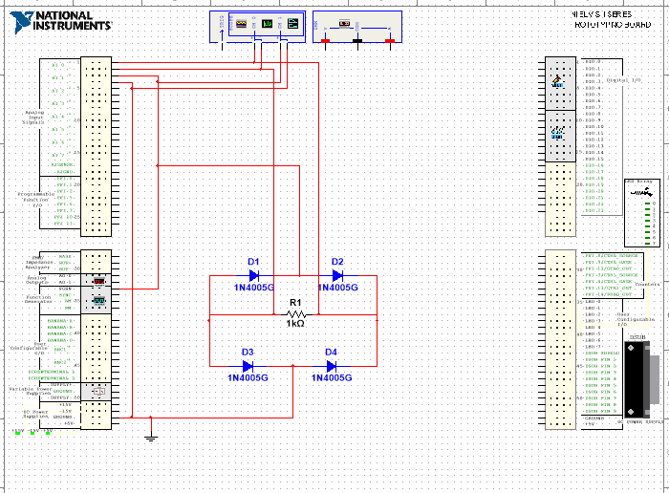

Figure . Wiring the NI EVLIS II to Full-Wave Bride Rectifier

Run the simulation and function generator. Double click on NI’s oscilloscope and set the channel 0 source to AI 0 and enable channel 1 to AI 1’s source. Set the Trigger type to edge and ensure the slope is increasing with the level as 0V.

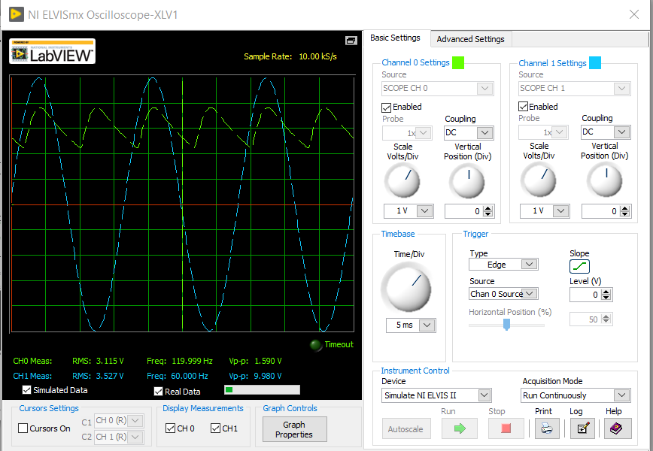

Figure . Oscilloscope Settings

**PART III:**

Take the circuit built in part II and add a 10uF capacitor to the load as follows:

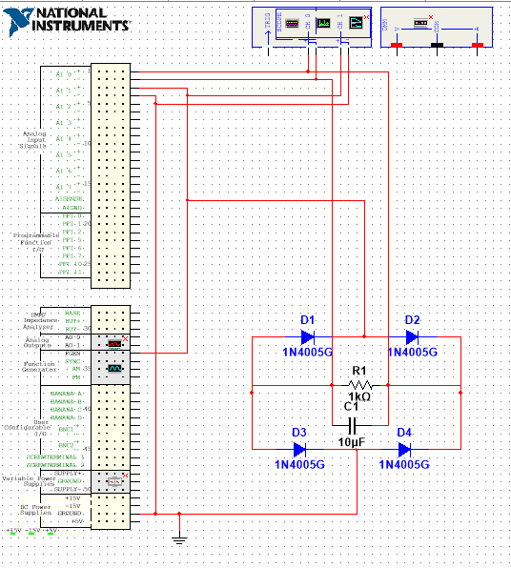

Figure . Part III circuit with capacitor setup

Run the simulation the same way as in Part II and configure the oscilloscope’s scale so that 2 or 3 cycles of the waveform are visible. Observe the AC “ripple” due to the capacitor maintaining a charge. Measure the ripple voltage and repeat/record results of the experiment for the following parameters: 1k load resistor, capacitor at 10uF, 100uF, and 500uF.

Repeat the experiment for the three capacitor values but this time with a 10k resistor. Record your results for further analysis.

**Results:**

* 1. **Simulation Results:**

**PART I:** The circuit to analyze the behavior of the diode rectifier:

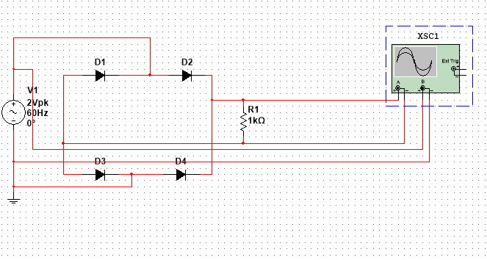

Figure . Bridge Rectifier Circuit

The behavior of the bridge rectifier can be seen below, notice how the negative polarity waveform gets inverted by the diodes.

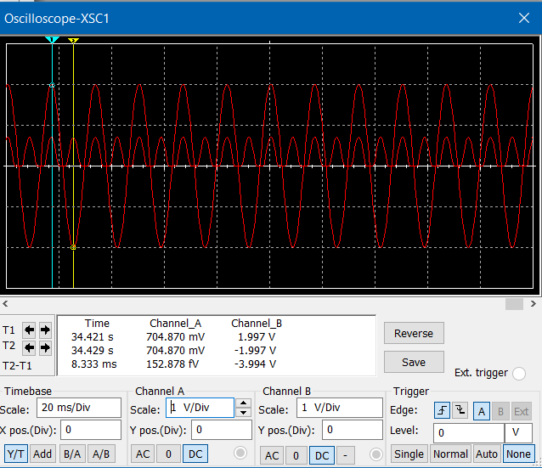

Figure . Bridge Rectifier Behavior

**PART II:**

Using the NI ELVIS II equipment the circuit is built as follows:

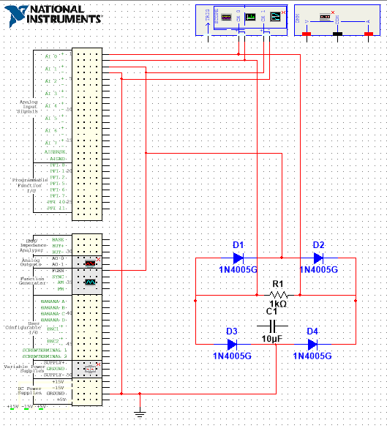

Figure . Rectifier using NI ELVIS II, without Capacitor

Upon running the simulation output graph from the oscilloscope compare the voltage across the load versus the source voltage. This graph compares to the graph generated within the first part of the lab to analyze the behavior of the bridge rectifier.

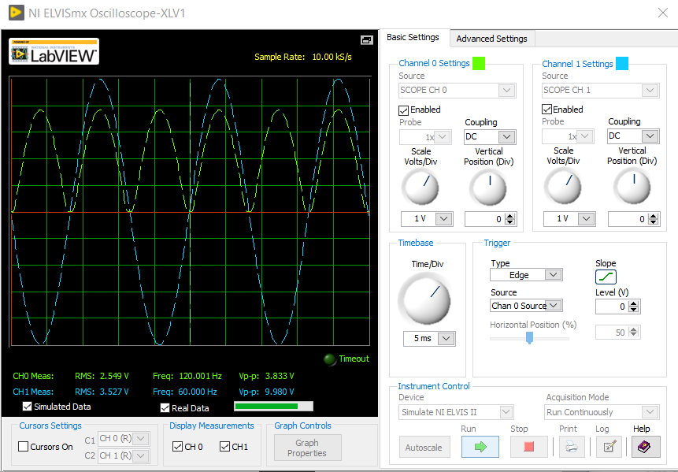

Figure . Oscilloscope Reading

By adding a capacitor to the circuit as follows:



Figure . Adding a Capacitor to the circuit

The three output oscilloscope graphs record the behavior of the circuit for when the load resistor is 1k, but the capacitor changes values of 10uF, 100uF, and 500uF:

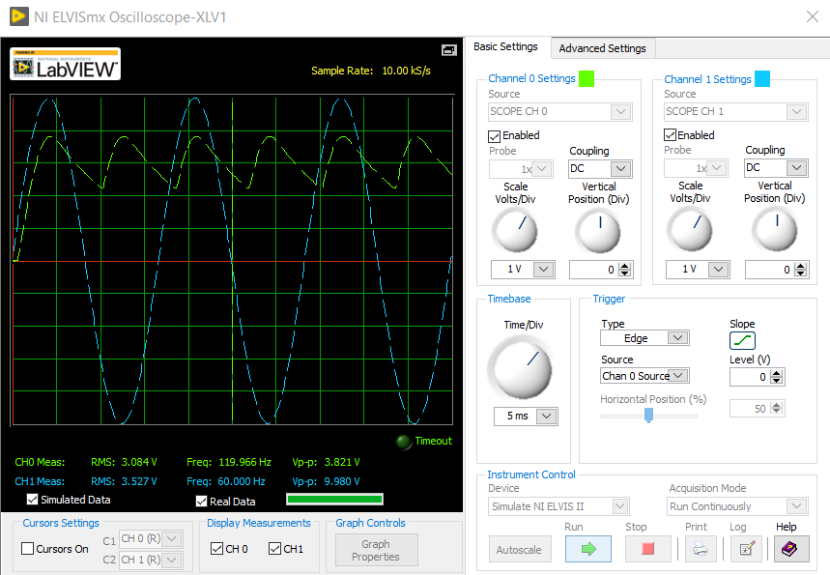

Figure . C=10uF

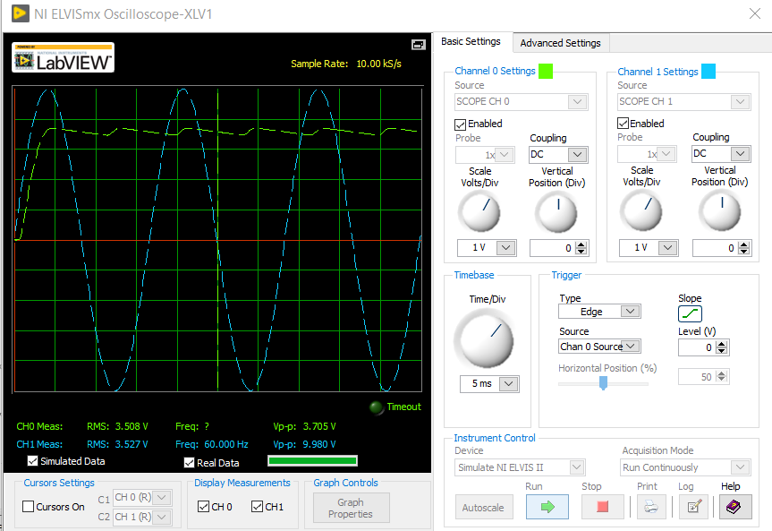

Figure . C=100uF

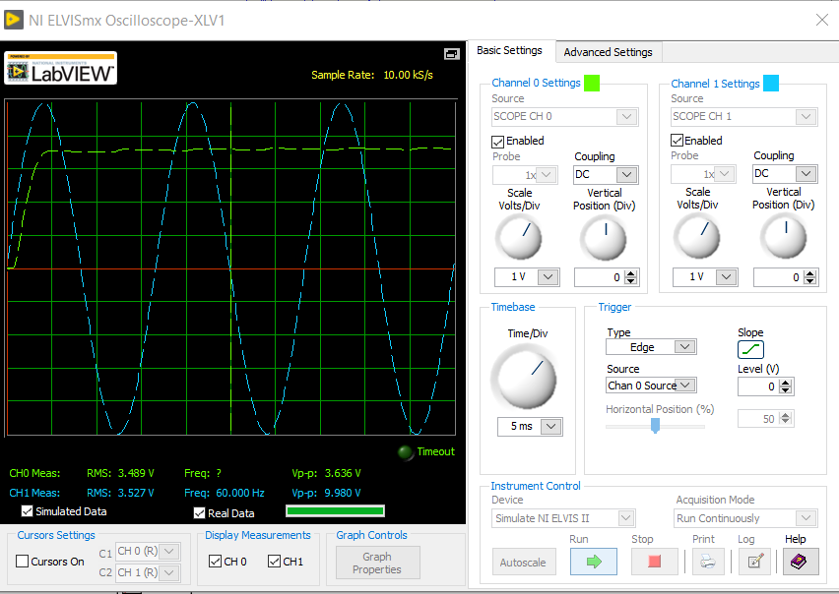

Figure . C=500uF

From the readings, the AC ripple voltage can be concluded as follows:

|  |  |  |  |
| --- | --- | --- | --- |
| **1K load** | **10uF** | **100uF** | **500uF** |
| **Ripple Voltage** | 3.821V | 3.705V | 3.636V |

Upon repeating the experiment but changing the load to 10k, the readings are as follows:

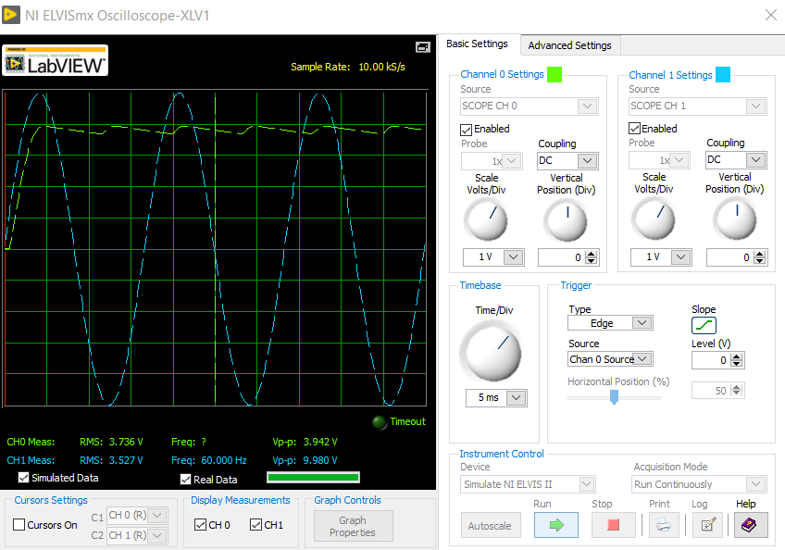

Figure . R=10k, C=10uF

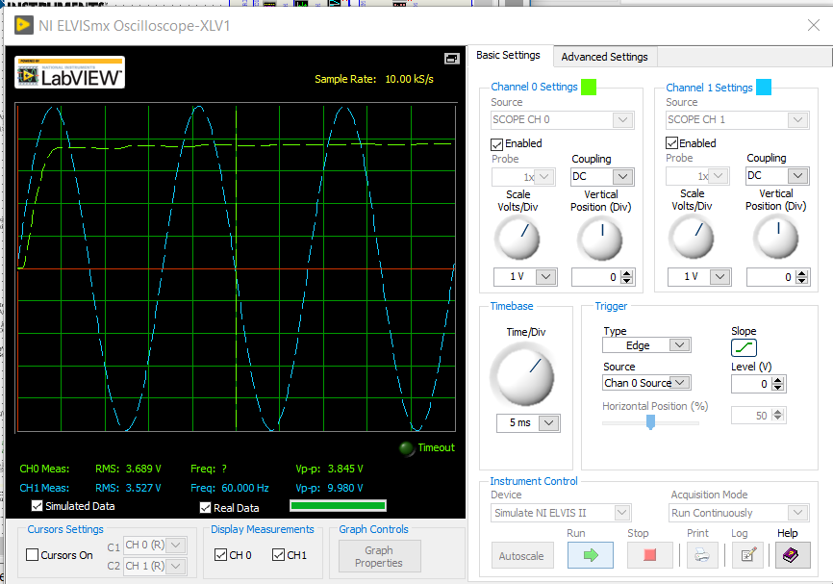

Figure . R=10k, C=100uF

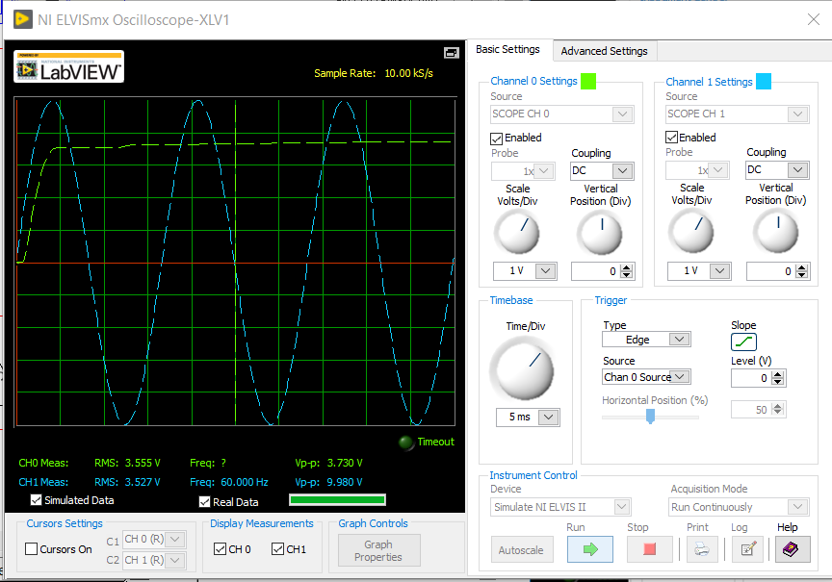

Figure . R=10k, C=500uF

|  |  |  |  |
| --- | --- | --- | --- |
| **10K load** | **10uF** | **100uF** | **500uF** |
| **Ripple Voltage** | 3.942V | 3.845V | 3.730V |

* 1. **Analysis:**

Comparing the graph’s between Part I and the simulation using the NI ELVIS II, it is apparent that both rectifiers are full-wave rectifiers, and they invert the negative polarity signal into positive waveforms. This is because when the wave form is within a positive polarity, current flows through D2, through the load resistor into D3 and loops back through the circuit while D1 and D4 blocks current. Upon a negative wave form, current flows through D4 into the load resistor and out into D1, while D2 and D3 block current from flowing.

When comparing the amplitude of voltage across the load, using a load of 10k versus 1k, the amplitude across the resistor is slightly higher, though both graphs are within 3-4V peaks. The voltage may be different within the simulation because Multisim’s voltage source is a fixed ideal voltage source, whilst the NI ELVIS II function generator is based upon the parameters of the real instrument, which has its own resistance. Furthermore, the diodes used within the simulation were ideal diodes, whilst the NI ELVIS II simulation used diodes modelled to simulate 1N4005G diodes which have their own parameters such as a saturation current of 5.316*10-8A, a parasitic resistance of 0.039Ω, an emission coefficient of 2, and a breakdown voltage of 600V. The ideal diode has no parasitic resistance, a significantly smaller saturation current and breakdown voltage, and emission coefficient of 1. Furthermore, if this simulation were performed on hardware, the load resistor and capacitors used would have their own tolerances.

Ripple voltage is the amount of AC voltage that appears on a DC voltage. Ripple voltage appears within the rectifier circuit since the rectifier converts AC to DC. By adding a capacitor to the circuit, the load resistor causes the capacitor to discharge some voltage between cycles. This is done to smooth out the ripple voltage into a constant DC voltage with a stable magnitude. By increasing the capacitance within the circuit, the voltage will level out more which can be seen by the resulting graphs above. By increasing resistance within the circuit to 10k, this limits the rate of current flowing through the circuit further, therefore it takes more time for the capacitor to discharge. This can be seen when comparing the c=10uF graphs for when the load is 1k vs 10k. Notice that the voltage is more levelled out because the capacitor is taking a longer time to discharge when R=10k than the time it takes when R=1k.

1. **Conclusion:**

This laboratory introduced simulation upon using the NI ELVIS II instruments within Multism, as well as explaining how the behavior of a full-bridge rectifier can convert AC voltage into DC voltage. Further analysis concluded that the addition of a capacitor can eliminate ripple voltage by discharging voltage. When increasing the overall impedance of the circuit, such as an increase of the load resistor, the capacitor will take a longer time to discharge the circuit, which in turn causes the ripple voltage to level out further into a constant DC voltage.